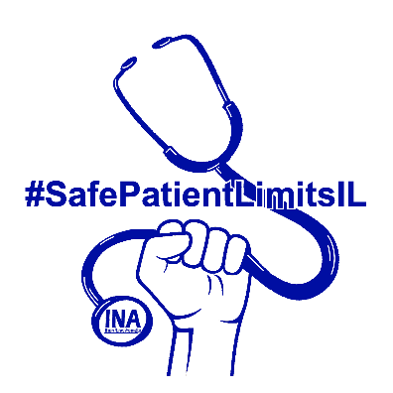

Safe Patient Limits Act

The Safe Patient Limits Act will save lives by designating limits on how many patients can be assigned to a registered nurse in acute care settings. Under current law in Illinois, there is no limit on how many patients an RN is responsible for.

Safe Patient Limits Are…

Safer for Patients

Published studies show that with each additional patient assigned to an RN, the likelihood of a patient dying within 30 days of admission increases, and the odds of death due to treatable complications increases by 7% for each additional patient assigned. Inpatient mortality rates were 17% lower on surgical units with higher RN to patient ratios in another study. In addition to reducing preventable deaths, higher RN to patient ratios diminish adverse outcomes such as, but not limited to, hospital-acquired infections, pneumonia, shock, gastrointestinal bleeding, and cardiac arrest.

Safer for Nurses

OSHA cited understaffing in healthcare as a risk factor for workplace violence. Another published study found that the safe patient limits enacted in California reduced occupational illness and injury rates of nurses by over 30%. Notably, the nursing occupation currently generates more occupational injuries to working women than any other occupation.

Better for Hospitals

There is a nursing shortage in Illinois and elsewhere, which is likely linked to unrealistic workloads. Nurses and nurse managers agree that maximum patient ratios improve recruitment and retention of nurses. The average cost to a hospital of turnover for a bedside RN is $49,500. Each percentage change in RN turnover will either save or cost the average hospital $337,500.

Details on how the Act protects patients and healthcare workers on reverse side
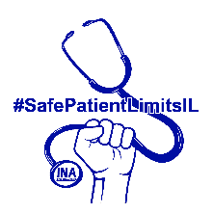
How the Act Works

The Act would provide for the following safe patient limits:

- no more than 4 patients to an RN in any acute care setting
- no more than 2 critical care patients to an RN
- no more than 3 stepdown/intermediate care patients to an RN
- no more than 1 PACU patient under 18 years old to an RN
- no more than 2 PACU patients 18 years or older to an RN
- no more than 1 OR patient to an RN, with at least 1 additional scrub assistant
- no more than 3 ER patients to an RN
- no more than 2 critical care ER patients to an RN
- no more than 1 trauma ER patient to an RN
- no more than 3 antepartum patients to an RN
- no more than 2 antepartum patients requiring continuous fetal monitoring to an RN
- no more than 1 active labor patient to an RN
- no more than 1 immediate postpartum couplet to an RN with an additional RN for each baby in the case of multiple births
- no more than 6 patients or 3 couplets to an RN postpartum
- no more than 4 pediatric patients to an RN
- no more than 4 psychiatric patients to an RN
- no more than 4 medical or surgical patients to an RN
- no more than 3 telemetry patients to an RN
- no more than 4 observational patients to an RN
- no more than 4 acute rehabilitation patients to an RN
- no more than 4 specialty care patients to an RN

The Act would apply broadly to any acute care unit in any healthcare facility, and require healthcare facilities to meet the safe patient limits without diminishing other healthcare staff. The Act would also provide for fines for facilities that violate the safe patient limits, strongly deterring the attempt to save money by skirting the limits.

The Act would also require that all registered nurses be trained, oriented, and meet competency requirements in a particular clinical setting in order to provide care in that setting.

The Act would not interfere with the ability of hospitals to maintain an acuity system to determine staffing levels based on acuity, so long as the specific safe patient limits in the Act are met.

